Profile of the

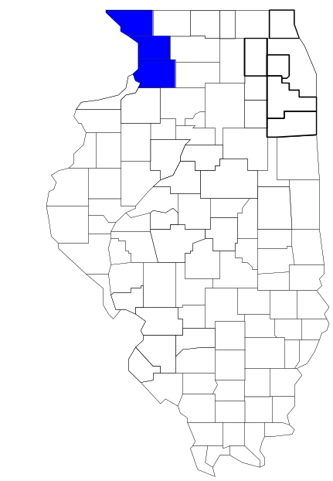Blackhawk Area Task Force

Prepared by

The Research and Analysis Unit of the
Illinois Criminal Justice Information Authority

George H. Ryan, Governor
Peter B. Bensinger, Chairman
Candice M. Kane, Executive Director

March 2001

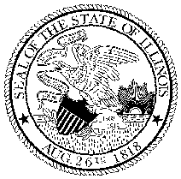

ILLINOIS
CRIMINAL JUSTICE
INFORMATION AUTHORITY

This project was supported by Grant # 99-DB-BX-0017, awarded to the Illinois Criminal Justice Information Authority by the Bureau of Justice Assistance, Office of Justice Programs, U.S. Department of Justice. The Assistant Attorney General, Office of Justice Programs, coordinates the activities of the following programs, offices and bureaus: Bureau of Justice Assistance, Bureau of Justice Statistics, National Institute of Justice, Office of Juvenile Justice and Delinquency Prevention, and the Office for Victims of Crime. Points of view or opinions contained within this document are those of the authors and do not necessarily represent the official position or policies of the U.S. Department of Justice.

Illinois Criminal Justice Information Authority
120 S. Riverside Plaza, Suite 1016
Chicago, Illinois 60606-3997
Telephone (312) 793-8550
Telefax (312) 793-8422
TDD: (312) 793-4170
World Wide Website http://www.icjia.state.il.us
ACKNOWLEDGMENTS

A number of organizations and individuals put a great deal of effort into the development of this document. The Authority’s Research and Analysis Unit is very grateful for the assistance provided by the following organizations:

Administrative Office of the Illinois Courts
Illinois Department of Human Services’ Office of Alcoholism and Substance Abuse
Illinois Department of Children and Family Services
Illinois Department of Corrections
Illinois State Police
Blackhawk Area Task Force
U.S. Bureau of the Census

In addition, the following individuals were instrumental in gathering, interpreting and presenting these data:

Sharyn Adams

Megan Alderden

Robert Bauer

Alissa Clark

John Condne

Karen Griffiths

Tracy Hahn

Jennifer Hiselman

David Katz

Joseph Kozenczak

Gary Kupsak

Erica Morrow

David Olson

Adrianna Perez

Gerard Ramker

Robert Taylor

CONTENTS

Section Page Number

EXECUTIVE SUMMARY

I. Introduction 1
II. Trends in Violent Index Offenses and Arrests 3
III. Trends in Drug Arrests 6
IV. Trends in Drug Seizures 15
V. Trends in Prosecutions for Drug Offenses 17
VI. Trends in Percent of Convicted Drug Offenders Sentenced to Prison 19
VII. Trends in Drug Treatment Admissions in BATF Region by Drug Type 24
VIII. Trends in Drug Exposed Births 27
IX. Summary of Drug Situation 28
X. Appendices 31
Map 1 1999 Percent of Illinois' County-level Population Covered by an
Authority-funded Multi-jurisdictional Enforcement Group or Task Force 32
Map 2 1999 Illinois Cannabis Seizure Rates, by County 33
Map 3 1999 Illinois Controlled Substances Seizure Rates, by County 34
Map 4 1999 Illinois Methamphetamine Seizure Rates, by County 35
XI. Bibliography 36

LIST OF FIGURES

Figure Page Number

Figure 1. Violent Index Offense Rates for Participating and Non-participating
Agencies in Region Covered by BATF 3
Figure 2. 1999 Violent Index Offenses* Reported by Participating and
Non-participating Agencies in Region Covered by BATF 4
Figure 3. Violent Index Arrest Rates for Participating and Non-participating
Agencies in Region Covered by BATF 5
Figure 4. 1999 Violent Index Arrests* Reported by Participating and
Non-participating Agencies in Region Covered by BATF 5
Figure 5. Total Drug Arrest Rates for BATF and Participating and
Non-participating Agencies in Region Covered by BATF 7
Figure 6. 1999 Drug Arrests* Reported by Participating and Non-participating
Agencies in Region Covered by BATF 8
Figure 7. Total 1999 Drug Arrests* Reported by Participating and
Non-participating Agencies in Region Covered by BATF, by Drug Type 8
Figure 8. Drug Arrests by BATF 9
Figure 9. Percent of Total Drug Arrests Accounted for by BATF 9
Figure 10. Cannabis Arrests Rates in the Region Covered by BATF as
Reported by Participating Agencies, Non-participating Agencies and BATF 11
Figure 11. Percent of Cannabis Arrests Accounted for by BATF
12
Figure 12. Controlled Substances Arrest Rates in the Region Covered by BATF as
Reported by Participating Agencies, Non-participating Agencies and BATF 13
Figure 13. Percent of Controlled Substances Arrests Accounted for by BATF 14
Figure 14. BATF Drug Arrests for Possession versus Delivery, by Drug Type 14
Figure 15. Cannabis Seized and Submitted to ISP by Carroll, Jo Daviess and
Whiteside Counties and Seized by BATF 15
Figure 16. Powder and Crack Cocaine Seized and Submitted to ISP by Carroll,
Jo Daviess and Whiteside Counties and Seized by BATF 16
Figure 17. Number of Felony Filings in Carroll, Jo Daviess and Whiteside Counties 17
Figure 18. Total BATF Drug Arrests and Prosecutions 18
Figure 19. Sentences Imposed on Felons Convicted in Carroll, Jo Daviess and
Whiteside Counties
19
Figure 20. Sentences Imposed on Convicted BATF Drug Offenders 20
Figure 21. Number of Drug Offenders Committed to IDOC by BATF and Region
Covered by BATF 21
Figure 22. Drug Offenders as a Percent of Total IDOC Commitments from
Carroll, Jo Daviess and Whiteside Counties 22
Figure 23. Drug Offenders Committed to IDOC from Carroll, Jo Daviess and
Whiteside Counties, by Offense Class 23
Figure 24. Substance Abuse Treatment Admissions from Carroll, Jo Daviess and
Whiteside Counties 24
Figure 25. Comparison of Drug Arrests by BATF and Participating and
Non-participating Agencies vs. Drug Abuse Treatment Admissions in
Carroll, Jo Daviess and Whiteside Counties, 1999 26
Figure 26. Cases of Drug-Exposed Infants in Carroll, Jo Daviess and Whiteside
Counties 27
Figure 27. Availability of Drugs in Illinois, 1998 28
Figure 28. Price Per Gram in Illinois, 1998 29
EXECUTIVE SUMMARY

Since 1989, the Authority’s Research and Analysis Unit has received funds under the federal Anti-Drug Abuse Act of 1988 to document the extent and nature of drug and violent crime in Illinois and the criminal justice system’s response to these offenses. As a result of these efforts, the Authority has amassed a large amount of data measuring the extent and nature of drug and violent crime in Illinois and the impact these crimes have had on the criminal justice system. In addition, as part of its monitoring and evaluation efforts, the Authority also requires funded programs to submit monthly data reports describing their activities and accomplishments. This profile is intended to provide a general overview of the drug and violent crime problem in the jurisdictions covered by Illinois’ MEGs and task forces, and the response to these problems by the units.

Although the data presented in this report are by no means inclusive of all indicators, they do provide a general overview of drug and violent crime and the response and impact of the criminal justice system. The following represent general conclusions that can be made based on the data analyzed for this report.

- In 1999, five local Illinois police agencies participated in BATF (a participating agency is defined as one that contributes either personnel or financial resources to BATF). Officers assigned to BATF (totaling 11 in 1999, five from participating agencies) accounted for only five percent of the total number of sworn police officers working for agencies participating in BATF.

- The violent Index offense rate was collectively higher across jurisdictions that did not participate in BATF than among the combined jurisdictions that did participate in BATF, although the difference has become less dramatic since 1997 (page 3).

- The total drug arrest rate tended to be slightly higher in the jurisdictions that did not participate in BATF than in those jurisdictions that did participate in BATF, although drug arrests rates in both participating and non-participating jurisdictions increased considerably during the period examined. Also, the BATF accounted for a substantial proportion of the drug arrests made in the jurisdictions participating in the unit. During the period examined, BATF accounted for one-half or more (depending on the specific drug offense considered) of the drug arrests made in the region, despite the fact that the unit includes only a small proportion of all officers working in the region covered by BATF (page 6).

- When comparing the types of drug offenders arrested by those agencies participating in BATF, those agencies not participating, and BATF, it was found that BATF tended to target and arrest more serious drug law violators, specifically violators of the Controlled Substances Act, which tend to be felony-level offenses (page 9).

- The majority of all drug arrests reported by BATF, for either violations of the Cannabis Control Act or the Controlled Substances Act, involve drug sale or delivery (page 14).

- Although cannabis seizures by BATF decreased between 1993 and 1999, the amount of cocaine seized during this time increased dramatically (pages 15 and 16).

- Between 1991 and 1999, almost every drug arrest by BATF resulted in prosecution. Of these BATF drug offender prosecutions, almost 64 percent were for violations of the Controlled Substance Act (page 18).

- In 1999, among those BATF drug offenders convicted and sentenced, prison sentences accounted for the largest proportion (42 percent), followed by jail sentences (39 percent) and probation sentences (18 percent) (page 20).

- Between 1989 and 1999, prison sentences resulting from BATF cases accounted for 51 percent of all drug-law violators sent to prison from the region where BATF operates (page 21).

- Unlike the arrests made by participating and non-participating agencies, the arrests made by BATF tended to involve the substances considered to be most serious (i.e., felony versus misdemeanor) and the substances for which a large proportion of community residents were seeking and receiving substance abuse treatment (page 25).

I. Introduction

The Blackhawk Area task force (BATF) covers the Illinois counties of Carroll, Jo Daviess and Whiteside. Combined, these counties had a 1999 total population of 97,859 – a slight decrease (1 percent) from the 1990 population. In 1999, five local Illinois police agencies participated in BATF. These include the Carroll County Sheriff's Office, the Jo Daviess County Sheriff's Office, the Whiteside County Sheriff’s Office, and the municipal police departments of Sterling and Morrison. These agencies served 60 percent of the population in the three-county region covered by BATF in 1999 (see Map 1 on page 32). In addition, the following Iowa law enforcement agencies also participate in BATF: the Clinton Police Department, Clinton County Sheriff’s Office, and the Jackson County Sheriff’s Office. A participating agency is defined as one that contributes either personnel or financial resources to BATF.

In addition to agencies that participate in BATF, these Illinois counties are served by 21 additional police departments that do not participate in BATF. According to the Illinois State Police, county sheriffs and local police departments in the three-county region covered by BATF, combined, employed 166 full-time police officers as of Oct. 31, 1999, 91 of which were employed with agencies participating in BATF. In comparison, there were just 11 officers assigned to BATF in 1999, five of which were assigned by participating agencies, two from the Illinois State Police and two from Iowa law enforcement agencies. Thus, the officers assigned to BATF during 1999 accounted for a relatively small proportion—five percent—of the total number of sworn police officers working in the participating police departments.

Since 1989, the Authority’s Research and Analysis Unit has received funds under the federal Anti-Drug Abuse Act of 1988 to document the extent and nature of drug and violent crime in Illinois and the criminal justice system’s response to these offenses. As a result of these efforts, the Authority has amassed a large amount of data measuring the extent and nature of drug and violent crime in Illinois and the impact these crimes have had on the criminal justice system. In addition, as part of its monitoring and evaluation efforts, the Authority also requires funded programs to submit monthly data reports describing their activities and accomplishments. To put this information into the hands of Metropolitan Enforcement Group (MEG) and drug task force directors and policy board members, the Authority’s Research and Analysis Unit has developed profiles – of which this is one – for each MEG and task force. The profile is intended to provide a general overview of the drug and violent crime problem in the jurisdictions covered by Illinois’ MEGs and task forces, and the response to these problems by the units.

In addition to administering federal block-grant funds that come to Illinois for crime control initiatives, the Illinois Criminal Justice Information Authority is also responsible for providing policymakers, criminal justice professionals and others with information, tools and technology needed to make effective decisions that improve the quality of criminal justice in Illinois. The Authority provides an objective system-wide forum for identifying critical problems in criminal justice, developing coordinated and cost-effective strategies, and implementing and evaluating solutions to those problems. The specific powers and duties of the Authority are delineated in the Illinois Criminal Justice Information Act (Illinois Compiled Statutes, Ch. 20, Sec. 3930). Two of the Authority’s many responsibilities are serving as a clearinghouse of information and research on criminal justice and undertaking research studies to improve the administration of criminal justice.

While the data presented in this report are by no means inclusive of all indicators, they do provide a general overview of drug and violent crime and the response and impact of the criminal justice system. In addition, these data are readily available and consistently defined through existing statewide data collection mechanisms. Some data presented in this profile have been analyzed differently than in previous years; therefore, caution must be taken when comparing numbers presented with previous profiles.
While a considerable amount of the information presented in this profile has been provided to the Authority by BATF, a number of state agencies have also provided data to the Authority that are included in this report. Specifically, the Illinois State Police, the Administrative Office of the Illinois Courts, the Illinois Department of Human Services’ Office of Alcoholism and Substance Abuse, the Illinois Department of Corrections and the Illinois Department of Children and Family Services all provided data used to develop this profile. The support and cooperation of these agencies and their staffs have helped make this report an informative and timely source of information on the activities of the criminal justice system in Illinois.

- Trends in Violent Index Offenses and Arrests

While most of Illinois’ Metropolitan Enforcement Groups and drug task forces are primarily involved in drug enforcement activities, it is clear that the relationship between drugs and violence is particularly evident in a number of Illinois communities. In addition, a number of MEGs and task forces have increased their involvement in the investigation of violent crime, particularly that associated with gang activity and violence related to drug distribution, sale and turf battles. One of the most commonly used indicators of the level of crime in a particular jurisdiction is the number of Index offenses reported to the police. In Illinois, as part of the Illinois Uniform Crime Reporting (I-UCR) program, every law enforcement agency in the state is required to report crime data monthly to the Illinois State Police (ISP). There are eight separate offenses that constitute the Crime Index, including murder, criminal sexual assault, robbery, aggravated assault (violent Index offenses), burglary, theft, motor vehicle theft and arson (property Index offenses). Although these eight offenses do not account for all crimes reported to the police, they are considered to be the most serious, frequent, pervasive and consistently defined by different law enforcement agencies.

In 1999, the number of violent Index offenses reported to the police in the three-county region covered by BATF totaled 225, a 41 percent decrease from the 379 offenses reported in 1993. The majority (79 percent) of violent Index offenses reported to the police between 1993 and 1999 were aggravated assaults, while 18 percent were criminal sexual assaults.

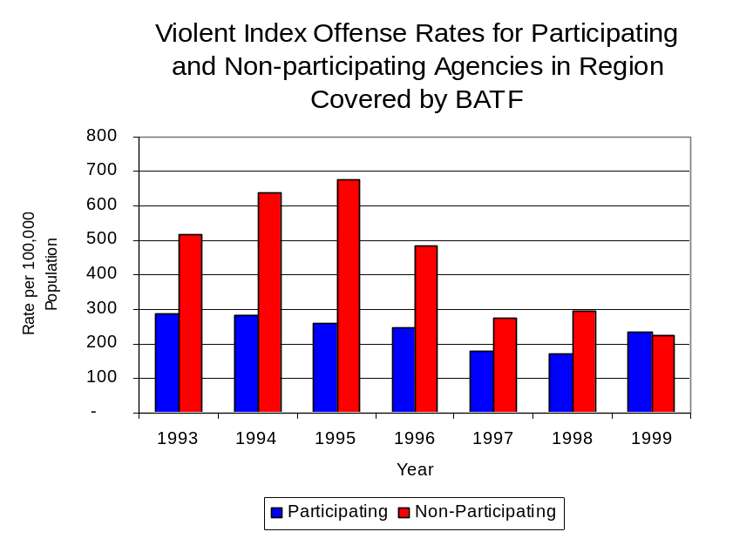
During the period analyzed, the violent Index offense rate for the region covered by BATF decreased 40 percent, from 383 offenses per 100,000 population in 1993 to 230 offenses per 100,000 population in 1999. Considering only the participating agencies, the violent Index offense rate decreased 19 percent, from 288 to 235 offenses per 100,000 population. During the same period, the rate in the non-participating agencies decreased 57 percent, from 518 to 222 offenses per 100,000 population (Figure 1). Thus, the violent Index offense rate was collectively higher across jurisdictions that did not participate in BATF than among the combined jurisdictions that did participate in BATF, although the difference has become less dramatic since 1997.
Figure 1
Source: ICJIA calculations using Illinois State Police and U.S. Census Bureau data

Across the 26 individual local law enforcement agencies covered by BATF’s jurisdiction, four agencies, the Sterling Police Department, Jo Daviess County Sheriff’s Office, Rock Falls Police Department and the Whiteside County Sheriff’s Office, accounted for 71 percent of all violent Index offenses reported to police (Figure 2). Fourteen agencies had fewer than five violent offenses reported in 1999 and are excluded from Figure 2; this includes six agencies that reported zero offenses. Two agencies serving smaller jurisdictions reported through another agency, and are also excluded from Figure 2. When controlling for differences in the populations served by these law enforcement agencies, the violent Index offense rate ranged from 604 violent Index offenses per 100,000 population in East Dubuque to 14 offenses per 100,000 population in unincorporated Carroll County.
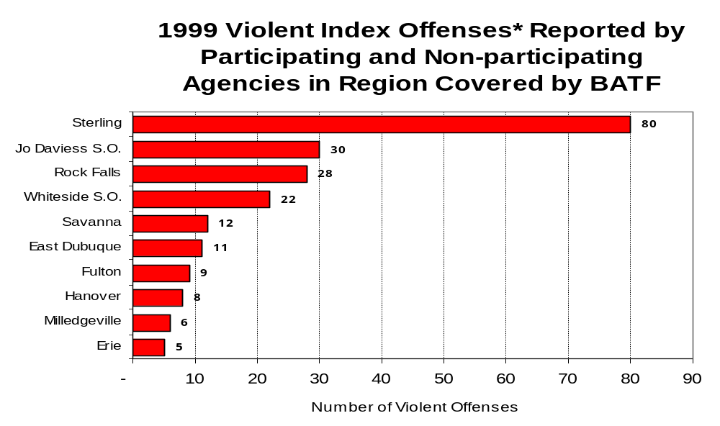
Source: Illinois State Police *Agencies reporting five or more violent offenses
Figure 2

An indicator of the workload that law enforcement agencies place on other components of the justice system is the number of arrests made by police, including those for violent and property Index offenses and drug offenses. Unlike offenses, which are what police must respond to, arrests represent those offenders who may eventually be processed through other components of the justice system, including the courts, county jails, and state and local correctional programs.

Between 1993 and 1999, the number of arrests for violent Index offenses made by law enforcement agencies in the region covered by BATF decreased 22 percent, from 200 to 156. As with reported violent Index offenses, the majority (86 percent) of violent Index arrests were for aggravated assaults, followed by criminal sexual assaults (11 percent) during the period analyzed.

During the period analyzed, the violent Index arrest rate for the region covered by BATF decreased 21 percent, from 202 arrests per 100,000 population in 1993 to 159 arrests per 100,000 population in 1999. The violent Index arrest rate in the participating agencies increased 10 percent, from 137 to 151 offenses per 100,000 population, while the rate in the non-participating agencies decreased 42 percent, from 295 to 172 offenses per 100,000 population (Figure 3).

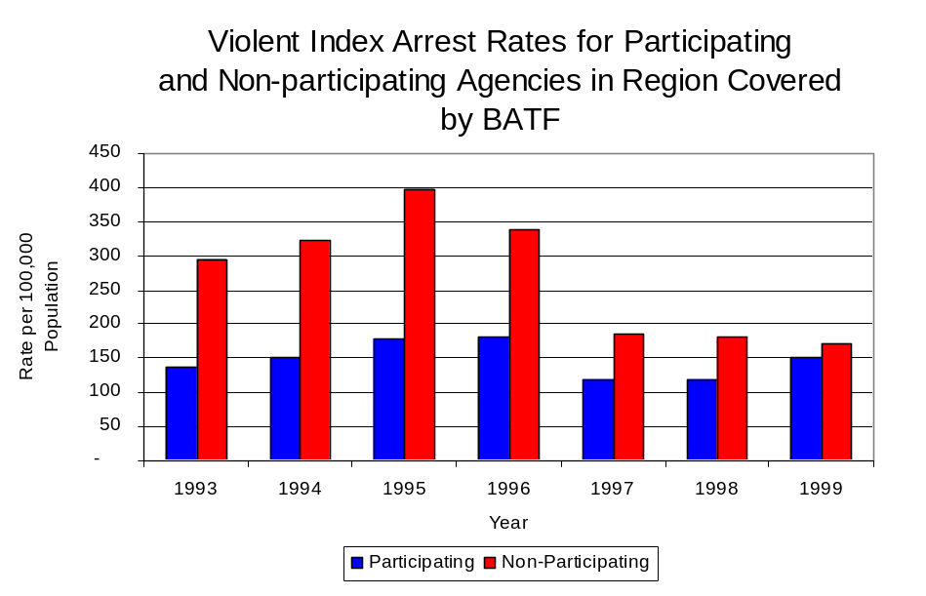
Figure 3
Source: ICJIA calculations using Illinois State Police and U.S. Census Bureau data

Similar to the number of violent Index offenses, the majority (67 percent) of arrests for violent

Index offenses occurring in the three-county region covered by BATF were made by four agencies. Sixteen agencies had fewer than five arrests for violent Index offenses reported in 1999 (including six agencies that reported zero arrests), and are excluded from Figure 4. Of the 156 violent Index arrests made in 1999, the Sterling Police Department accounted for the largest portion (28 percent), followed by the Rock Falls Police Department and the Jo Daviess County Sheriff’s Office (14 percent each) and the Whiteside County Sheriff’s Office (11 percent) (Figure 4).

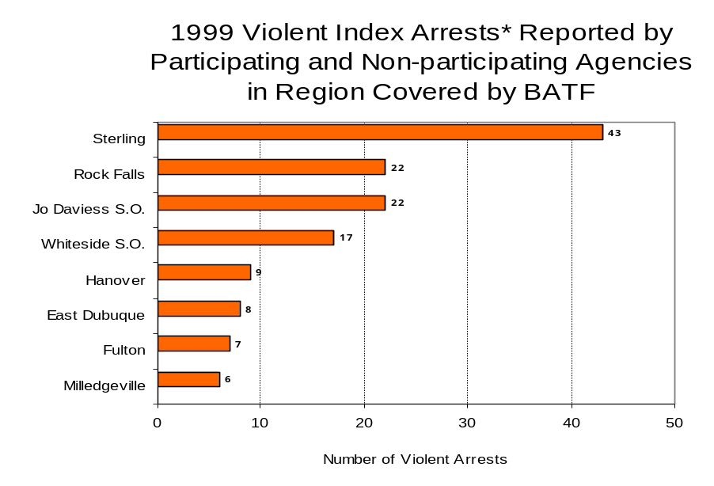
Figure 4
Source: Illinois State Police* Agencies reporting five or more violent Index arrests

III. Trends in Drug Arrests

There are two sources of drug arrest data presented in this section. One source is the Illinois Uniform Crime Reporting (I-UCR) program that includes information submitted by local law enforcement agencies on the number of persons arrested for violations of Illinois’ Cannabis Control Act, Controlled Substances Act, Hypodermic Syringes and Needles Act, and Drug Paraphernalia Control Act. In addition, data on drug arrests made by Illinois’ MEGs and task forces are reported to the Illinois Criminal Justice Information Authority. In some jurisdictions, arrests made by the MEG or task force may be reported by both local law enforcement agencies through the I-UCR and to the Authority by the unit. In other jurisdictions, arrests made by the MEG or task force are only reported to the Authority by the unit. Therefore, in some instances drug arrests may be double counted – included in both local agency statistics reported to I-UCR and those of the MEG or task force. Currently there is no mechanism in place to ensure that drug arrest statistics are not being duplicated at both the local agency and MEG/task force level. This should be considered when interpreting the information presented in the following section.

The majority of drug offenses in Illinois are violations of either the Cannabis Control Act – which prohibits the possession, sale and cultivation of marijuana – or the Controlled Substances Act – which prohibits the possession, sale, distribution or manufacture of all other illegal drugs, such as cocaine and opiates. Illinois also has various other laws prohibiting other drug-related activity. These include the Hypodermic Syringes and Needles Act – which prohibits the possession or sale of hypodermic instruments – and the Drug Paraphernalia Control Act – which prohibits the possession, sale or delivery of drug paraphernalia. In general, violations of Illinois Controlled Substances Act are considered to be more serious, since they primarily involve cocaine, heroin, methamphetamine, and hallucinogens, and are almost all classified under Illinois law as felonies. The majority of cannabis and drug paraphernalia offenses encountered by police, on the other hand, tend to be misdemeanor-level offenses.

In 1999, local law enforcement agencies in the counties covered by BATF reported 557 arrests for drug law violations, more than quadruple the number in 1993 (127 arrests). Between 1993 and 1999, arrests for violations of Illinois’ Cannabis Control Act out-numbered arrests for violations of the Controlled Substances Act every year in Carroll, Jo Daviess and Whiteside counties. During the same period, the number of arrests for violations of the Cannabis Control Act in these three counties combined increased from 93 to 260. Arrests for violations of the Controlled Substances Act in the three counties combined more than doubled, from 32 to 66. Arrests for violations of the Drug Paraphernalia Control Act, enacted in 1993, increased dramatically, from two in 1993 to 225 in 1999. Much of this increase can be attributed to a 1994 addition to the Drug Paraphernalia Control Act, which included the possession of drug paraphernalia as a violation.

Because arrests for violations of the Drug Paraphernalia Control Act are frequently made in conjunction with other drug offense arrests, these arrests may be double-counted, thus skewing the actual number of drug arrests. Therefore, only arrests for violations of the Cannabis Control Act and Controlled Substances Act will be used for drug arrest comparisons between BATF and the participating and non-participating agencies.

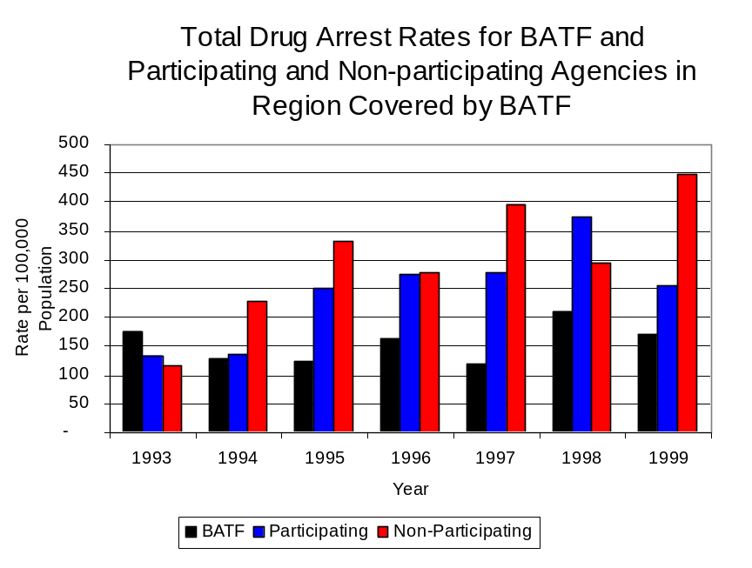
During the period analyzed, the drug arrest rate for the Cannabis Control and Controlled Substances Acts combined, in the region covered by BATF more than doubled, from 126 arrests per 100,000 population in 1993 to 333 arrests per 100,000 population in 1999. Similarly, the drug arrest rate in the participating and non-participating agencies also increased substantially, from 134 to 256 arrests per 100,000 population and 115 to 447 arrests per 100,000 population, respectively. The arrest rate for BATF, on the other hand, decreased slightly, from 177 to 172 arrests per 100,000 population (Figure 5). Thus, the drug arrest rate tended to be slightly higher in the jurisdictions that did not participate in BATF than in those jurisdictions that did participate in BATF. Also, the drug arrest rate achieved by BATF was half or greater than half the drug arrest rate achieved by participating agencies, meaning that the unit made almost as many arrests for violations of the Cannabis Control and Controlled Substances Acts combined, with only a small proportion of all officers working in the region covered by BATF.
Figure 5
Source: ICJIA calculations using Illinois State Police and U.S. Census Bureau data

Across the individual local law enforcement agencies in the region covered by BATF, the total number of arrests (including violations of the Cannabis, Controlled Substances, Drug Paraphernalia, and Hypodermic Needles and Syringes Acts) ranged from 116 to one (excluding the six agencies that made no drug arrests). Of the 557 drug arrests made during 1999 in the three-county region, four agencies accounted for 59 percent of these drug arrests. Fourteen agencies had fewer than 10 drug arrests reported in 1999 and are excluded from Figure 6, as well as the two agencies that report through another agency. The Whiteside County Sheriff’s Office accounted for 21 percent, while the Rock Falls and East Dubuque police departments accounted for 13 percent each. Sterling Police Department accounted for an additional 12 percent of all drug arrests in Carroll, Jo Daviess and Whiteside counties (Figure 6). Of the 12 agencies that reported the highest drug arrests, four were agencies participating in BATF.

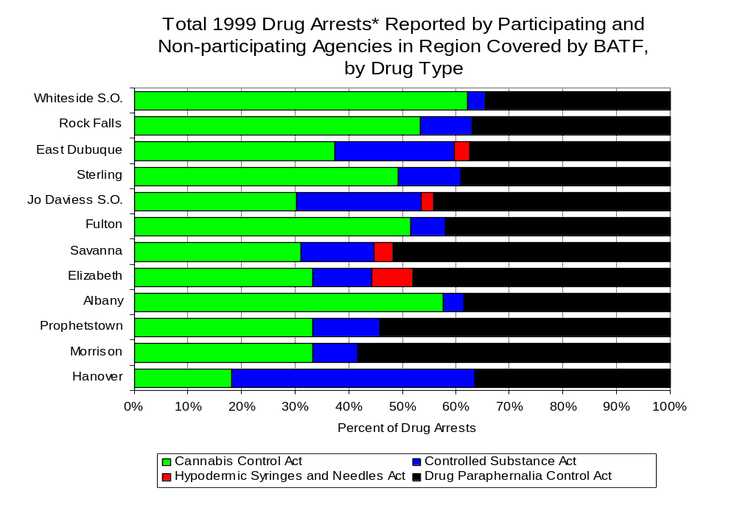
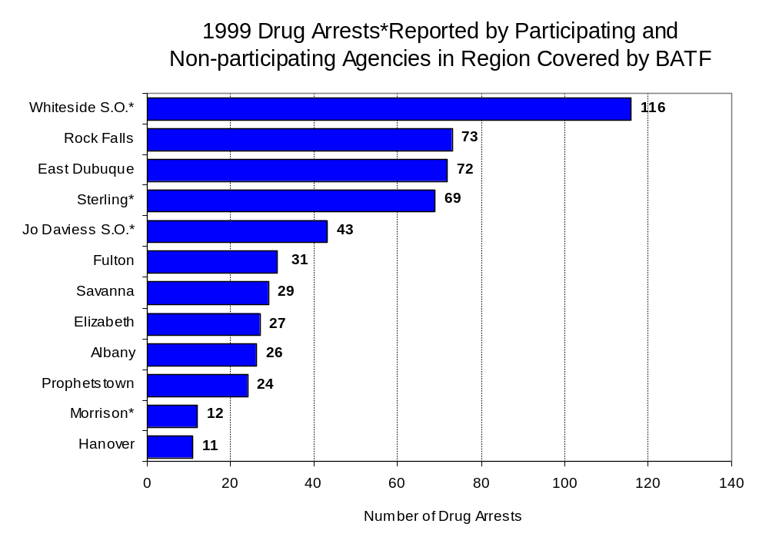
In addition to the dramatic difference in the number of drug arrests made, there are also differences in the types of drug law violation arrests across the agencies in the region. In 1999, violations of the Cannabis Control Act accounted for a substantial proportion of arrests across most individual agencies in the region covered by BATF, followed very closely by arrests for violations of the Drug Paraphernalia Control Act (Figure 7).
Figure 7
Source: Illinois State Police *Agencies reporting ten or more drug arrests
Figure 6
Source: Illinois State Police and BATF *Agencies participating in BATF
**Agencies reporting ten or more drug arrests

Between 1993 and 1999, the number of combined cannabis and controlled substances arrests made by BATF decreased three percent from 103 to 100 (Figure 8). Unlike drug arrests made by most local police departments in the region, violations of the Controlled Substances Act accounted for the majority of drug arrests made by BATF throughout most of the period analyzed. During the period analyzed, the number of BATF arrests for violations of the Cannabis Control Act decreased 69 percent, from 65 to 20, while arrests for violations of the Controlled Substances Act more than doubled, from 38 to 80 (Figure 8).

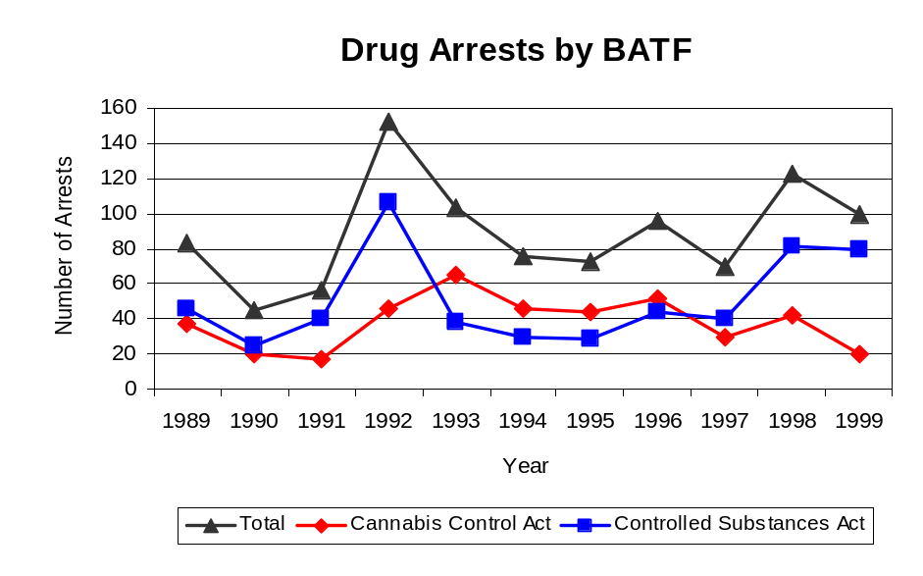
Between 1993 and 1999, the proportion of drug arrests accounted for by violations of the Controlled Substances Act decreased for participating agencies, but increased for non-participating agencies as well as BATF. In 1999, 16 percent of the drug arrests made by participating agencies were for violations of the Controlled Substances Act, compared to 29 percent in 1993. However, arrests for Controlled Substances Act violations accounted for 24 percent of the drug arrests made by the non-participating agencies in 1999, compared to 19 percent in 1993. The largest increase in proportion of arrests for Controlled Substances Act violations is noted with BATF. In 1999, 80 percent of BATF drug arrests were for Controlled Substances Act violations, compared to only 37 percent in 1993. One interpretation of this pattern may be that BATF is more focused than local departments in regards to who they are targeting and arresting. BATF is also getting a more serious drug law violators, since violations of the Controlled Substances Act are more likely to involve felony-level offenses.
Source: BATF
Figure 8

The data presented below represent the percent of total drug arrests made by participating agencies that were accounted for by BATF. An upper and lower bound is shown in Figure 9, which accounts for whether or not the units numbers are counted as part of the UCR submissions made by participating departments (which is unknown at this point). The upper bound indicates the percentage of arrests if all of the BATF arrests are included in the local UCR submissions. The lower bound indicates the percentage if none of the BATF arrests are included in the local UCR submissions. It is estimated that the proportion of all drug arrests made in the jurisdictions of participating agencies, and accounted for by BATF, was between 57 to over 100 percent in 1993, but decreased to between 40 to 67 percent in 1999. Thus, despite the fact that the officers assigned to BATF accounted for a small proportion of the total number of officers in participating agencies, they accounted for over 30 percent of the drug arrests made in the jurisdiction of the participating agencies in most of the years analyzed.

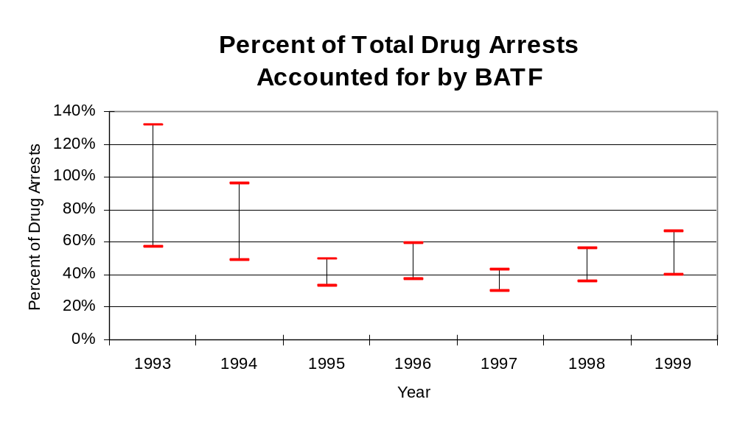
Figure 9
Source: ICJIA calculations using Illinois State Police
and BATF data
The number of arrests for violations of Illinois’ Cannabis Control Act in Carroll, Jo Daviess and Whiteside counties totaled 260 in 1999, nearly triple the 93 arrests made for cannabis violations in 1993. Between 1993 and 1999, the proportion of all drug arrests accounted for by violations of the Cannabis Control Act increased in the three-county region from 74 percent to 80 percent. Agencies not participating in BATF accounted for a slightly larger portion (52 percent) of the total number of arrests for cannabis violations than participating agencies in 1999. BATF reported a total of 20 arrests for cannabis violations in 1999, one-fifth of the unit's total drug arrests.

During the period analyzed, the cannabis arrest rate for the region covered by BATF nearly tripled, from 94 arrests per 100,000 population in 1993 to 266 arrests per 100,000 population in 1999. The cannabis arrest rate in the participating agencies more than doubled, from 94 to 214 arrests per 100,000 population, while the arrest rate in the non-participating agencies more than tripled from 93 to 341 arrests per 100,000 population. The cannabis arrest rate for BATF, on the other hand, decreased 69 percent, from 112 to 34 arrests per 100,000 population (Figure 10). Thus the arrest rate for violations of the Cannabis Control Act was collectively higher in the area served by non-participating agencies than in the combined jurisdictions of the participating agencies and BATF.

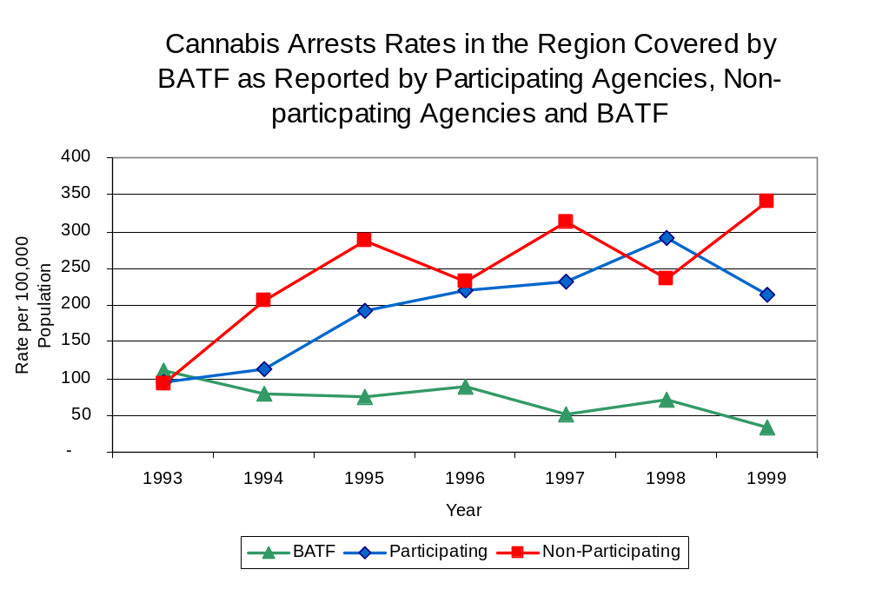
The data presented below represent the percent of total arrests for the violation of the Cannabis Control Act made by participating agencies that was accounted for by BATF. An upper and lower bound is shown in Figure 11, which accounts for whether or not the units numbers are counted as part of the UCR submissions made by participating departments (which is unknown at this point). The upper bound indicates the percentage of arrests if all of the BATF arrests are included in the local UCR submissions. The lower bound indicates the percentage if none of the BATF arrests are included in the local UCR submissions.
Figure 10
Source: ICJIA calculation using Illinois State Police
and BATF data

It is estimated that the proportion of all arrests for the violation of the Cannabis Control Act made in the jurisdictions of participating agencies, and accounted for by BATF, was between 54 to over 100 percent in 1993, but decreased to between 14 to 16 percent in 1999. The proportion of arrests made for the violation of the Cannabis Control Act by BATF in jurisdictions covered by participating agencies decreased during this time. The data presented in Figure 11 suggest that although arrests for the violation of the Cannabis Control Act made by BATf in 1993 and 1994 represented a large proportion of such arrests made in the jurisdictions of participating agencies, this proportion dropped in subsequent years.

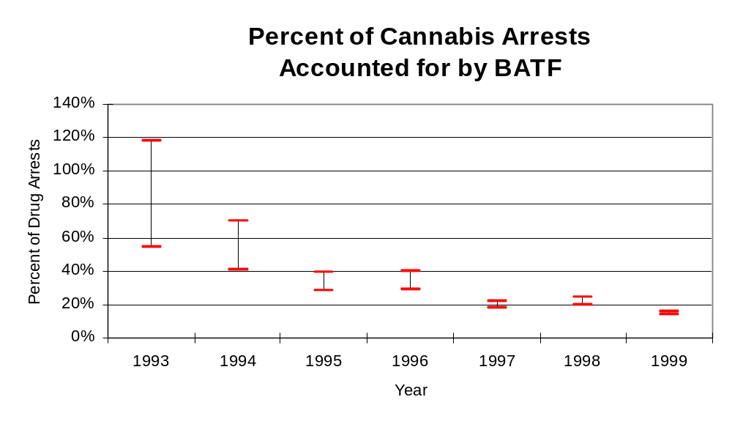
Figure 11
Source: ICJIA calculation using Illinois State Police, BATF
and U.S. Census Bureau data
In Carroll, Jo Daviess and Whiteside counties the number of arrests for violations of Illinois’ Controlled Substances Act more than doubled between 1993 and 1999, from 32 to 66. Between 1993 and 1999, the proportion of all drug arrests accounted for by violations of the Controlled Substances Act in the three-county region decreased from 26 percent to 20 percent. In 1999, BATF reported 80 arrests for controlled substance violations, 80 percent of all drug arrests reported to the Authority by the unit.

Between 1993 and 1999, the arrest rate for controlled substances act violations for the region covered by BATF more than doubled, from 32 to 67 arrests per 100,000 population (Figure 12). The controlled substances arrest rate in the participating agencies increased slightly, from 39 to 41 arrests per 100,000 population, while the arrest rate in the non-participating agencies increased nearly five-fold, from 22 to 106 arrests per 100,000 population. The controlled substances arrest rate for BATF more than doubled, from 65 to 137 arrests per 100,000 population (Figure 12). Thus, the arrest rate for violations of the Controlled Substances Act tended to be higher for BATF than across the jurisdictions of agencies participating in BATF and those not participating in BATF.

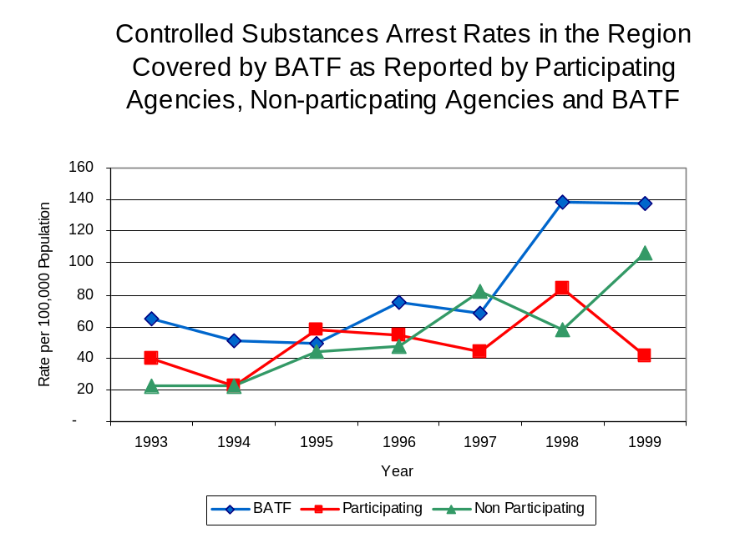
The data presented below represent the percent of total arrests for the violation of the Controlled Substances Act made by participating agencies that was accounted for by BATF. An upper and lower bound is shown in Figure 13, which accounts for whether or not the units numbers are counted as part of the UCR submissions made by participating departments (which is unknown at this point). The upper bound indicates the percentage of arrests if all of the BATF arrests are included in the local UCR submissions. The lower bound indicates the percentage if none of the BATF arrests are included in the local UCR submissions.
Figure 12
Source: ICJIA calculation using Illinois State Police, BATF
and U.S. Census Bureau data

It is estimated that the proportion of all arrests for the violation of the Controlled Substances Act made in the jurisdictions of participating agencies, and accounted for by BATF was between 62 percent to over 100 percent in 1993, and increased to between 77 percent to well over 100 percent in 1999. Unlike the arrests made by BATF for the violation of the Cannabis Control Act, arrests made by BATF for the Controlled Substances Act far exceeded the number of similar arrests made in the jurisdictions of the participating agencies. When examining the three figures together (Figure 9, 11 and 13), the data suggest that BATF focused on arresting individuals violating the Controlled Substances Act, most of which are felony offenses.

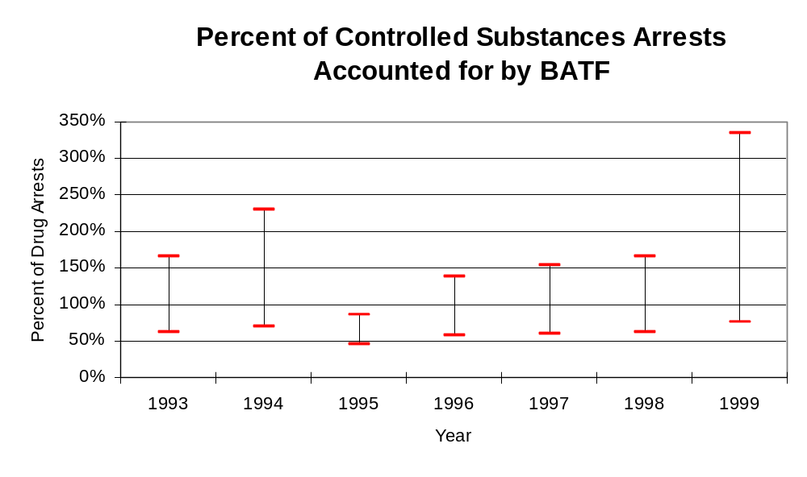
Source: ICJIA calculation using Illinois State Police
and BATF data
Figure 13
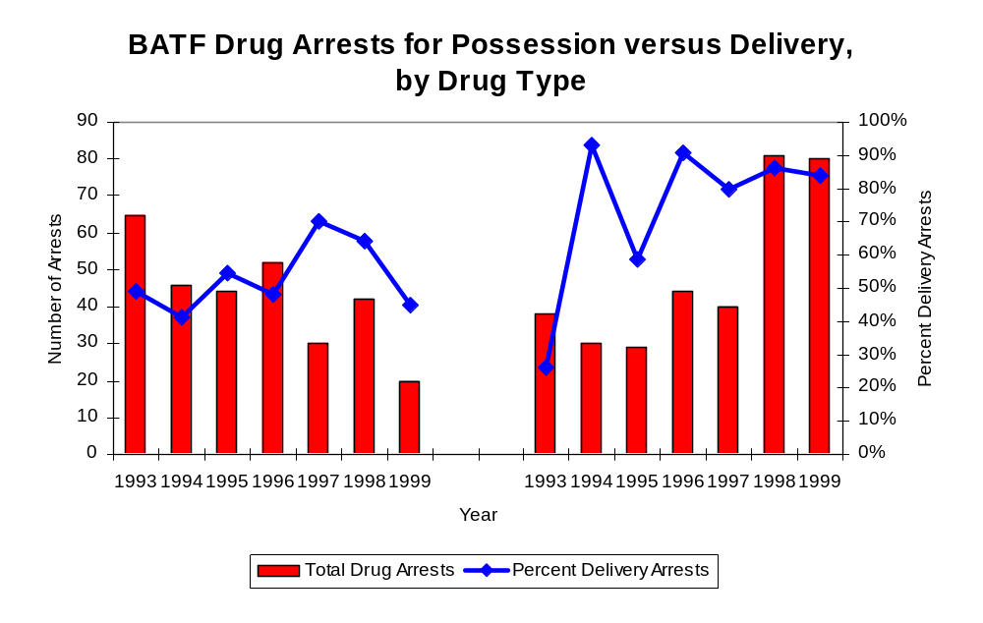
Figure 14 shows that the majority of all drug arrests reported by BATF are for delivery. Between 1993 and 1999, the number of drug delivery arrests made by BATF increased 27 percent, from 60 to 76. Arrests for drug delivery accounted for more than two thirds (68 percent) of all drug arrests made by BATF between 1993 and 1999. When cannabis and controlled substance arrests were examined separately, during the period analyzed, arrests for delivery of controlled substances accounted for 82 percent of the total number of arrests made for violations of the Controlled Substance Act, whereas arrests for the delivery of cannabis accounted for 53 percent of all arrests for violations of the Cannabis Control Act.
Source: ICJIA calculation using BATF data
Figure 14
Cannabis Control Act
Controlled Substances Act

IV. Trends in Drug Seizures

Drugs seized by law enforcement agencies are another indicator of the extent and nature of illegal drug trade in a jurisdiction. When illegal drugs are seized by law enforcement agencies, all or a portion of the total amount seized is submitted to a crime lab for analysis. Most agencies submit drugs to one of the Illinois State Police crime labs. These labs record the quantity of drugs submitted from each county. This section discusses trends in the quantities of illegal drugs seized and submitted to the Illinois State Police from local law enforcement agencies in Carroll, Jo Daviess and Whiteside counties as well as the quantities of drugs seized by BATF. It is important to note, however, that while BATF data report the total quantities of drugs actually seized, local agency data only represent the quantities of seized drugs that are submitted to the Illinois State Police for analysis. County-level cannabis, cocaine and methamphetamine seizure rates for Illinois' 102 counties are provided in maps located in the Appendix of this report.

As in most Illinois jurisdictions, cannabis accounts for the majority of illegal drugs seized in the three-county region covered by BATF. The quantity of cannabis seized and submitted by law enforcement agencies in Carroll, Jo Daviess and Whiteside counties decreased 77 percent, from 9,998 grams in 1993 to 2,317 grams in 1999. Similarly, the quantity of cannabis seized by BATF decreased 67 percent between 1993 and 1999, from 36,621 grams to 12,243 grams (Figure 15). In 1999, BATF's cannabis seizure rate of 21,003 grams per 100,000 population was about one-third lower than the statewide cannabis seizure rate of 31,533 grams per 100,000 population, but nearly nine times higher than the seizure rate of 2,368 grams per 100,000 population in the three-county region covered by BATF (Map 2).

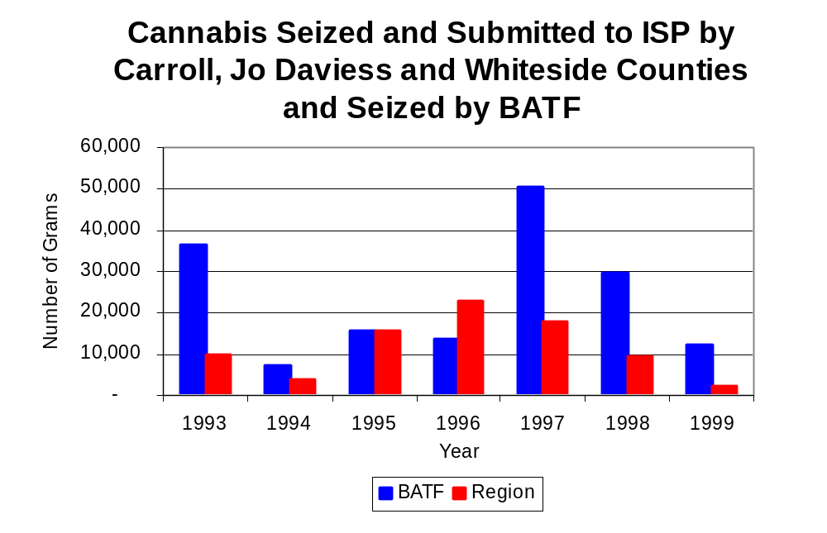
Figure 15
Source: Illinois State Police and BATF

Between 1993 and 1999, a combination of crack and powder cocaine has accounted for a small proportion of drugs seized in the three-county region covered by BATF. The quantity of cocaine seized and submitted by law enforcement agencies in Carroll, Jo Daviess and Whiteside counties has substantially decreased, from 2,830 grams in 1993 to 367 grams in 1999. However, much of this can be attributed to a large cocaine seizure in Whiteside County in 1993. Between 1993 and 1999, the quantity of cocaine seized by BATF more than doubled, from 388 grams to 909 grams.

The proportion of powder cocaine from all cocaine seized by local law enforcement agencies has remained relatively stable between 1993 and 1999 at above 95 percent throughout the period. For BATF, although powder cocaine accounted for the largest proportion of total cocaine seizures in six of the seven years examined, the proportion decreased from 100 percent in 1993 to 85 percent in 1999 (Figure 16). In 1999, BATF's cocaine seizure rate of 1,559 grams per 100,000 population was more than five times the cocaine seizure rate of 375 grams per 100,000 population in the three-county region covered by BATF, but only one-tenth of the statewide cocaine seizure rate of 15,735 grams per 100,000 population (Map 3).

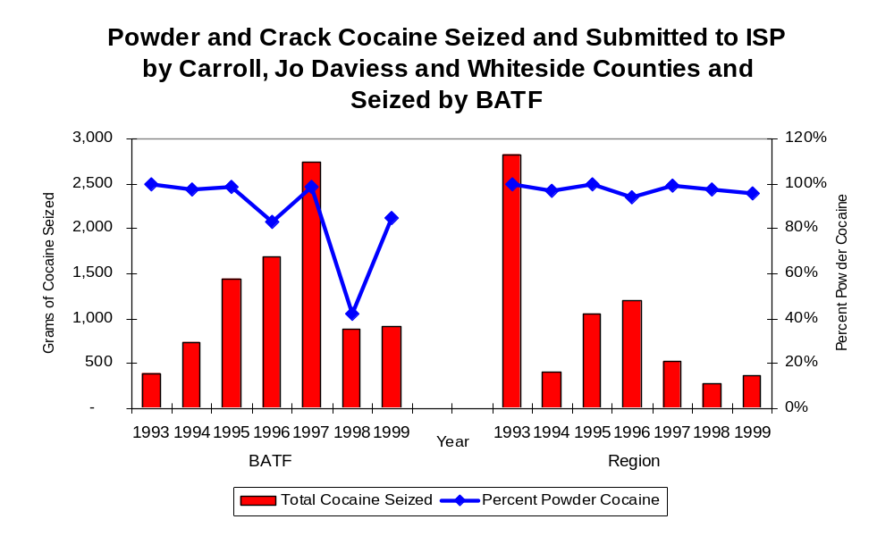
Source: ICJIA calculation using Illinois State Police and BATF data
Figure 16

The total quantity of illegal drugs seized and submitted by law enforcement agencies in Carroll, Jo Daviess and Whiteside counties decreased 77 percent between 1993 and 1999, from 12,870 grams to 2,938 grams, with a high of 24,054 grams seized in 1996. Similarly, the total quantity of illegal drugs seized by BATF has decreased 62 percent, from 37,092 grams in 1993 to 14,242 grams in 1999.

During the period, methamphetamine seizures accounted for a relatively small proportion of total drugs seized by BATF. However, in 1999, 645 grams of methamphetamine were seized by BATF resulting in a seizure rate of 1,106 grams per 100,000 population, significantly higher than statewide and regional seizure rates of 98 and 197 grams per 100,000 population, respectively (Map 4).

Trends in Prosecutions for Drug Offenses and All Felonies

Although Illinois has one of the best court reporting systems in the country, the Administrative Office of the Illinois Court only collects information regarding the aggregate number of court filings. Currently, there are no statewide data available on court filings by offense type. The Administrative Office of the Illinois Courts reports data on felony criminal court cases. After screening a case and deciding it warrants further action, the state’s attorney must file formal charges in court. Felony cases can be punished by a probation term up to four years and incarceration for more than one year.

Between 1989 and 1999, the number of felony filings in the three-county region covered by BATF increased about 6 percent, from 604 to 638 (Figure 17).

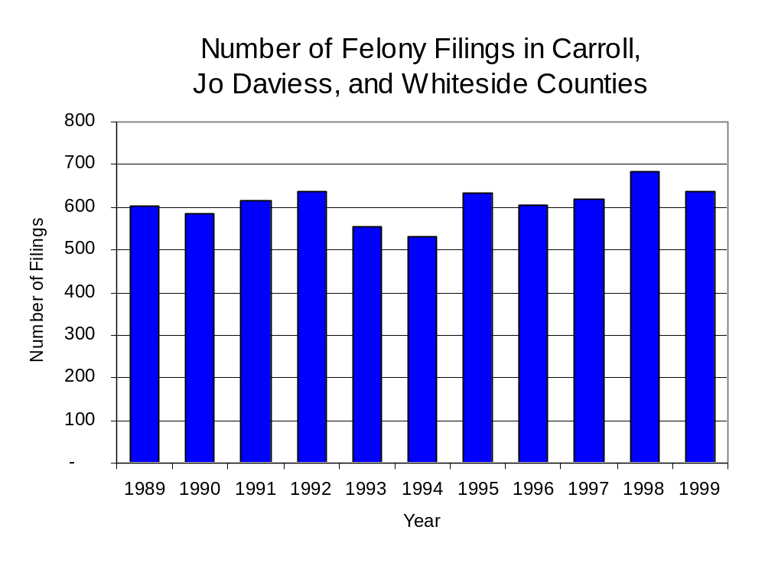
Figure 17
Source: Administrative Office of the Illinois Courts

Between 1989 and 1999, there were a total of 885 drug prosecutions initiated as a result of BATF arrests in Carroll, Jo Daviess and Whiteside counties. During this time, the number of BATF drug arrests increased 20 percent, from 83 arrests in 1989 to 100 arrests in 1999 (Figure 18). Similarly, the number of prosecutions resulting from BATF arrests nearly doubled from 50 in 1991 to 99 in 1999. Between 1991 and 1999, all of the drug arrests by BATF resulted in prosecution. Of these BATF drug offender prosecutions, about 64 percent were for violations of the Controlled Substance Act. In some years, the proportion of arrests resulting in a prosecution exceeded 100 percent. This may be due to some differences in the timing of an arrest and the filings of charges, or could be due to the number of charges, rather than the number of defendants being reported by the unit. In addition, some offenders have charges filed, and a subsequent warrant issued, without an arrest taking place, which could also affect the number of prosecutions reported.
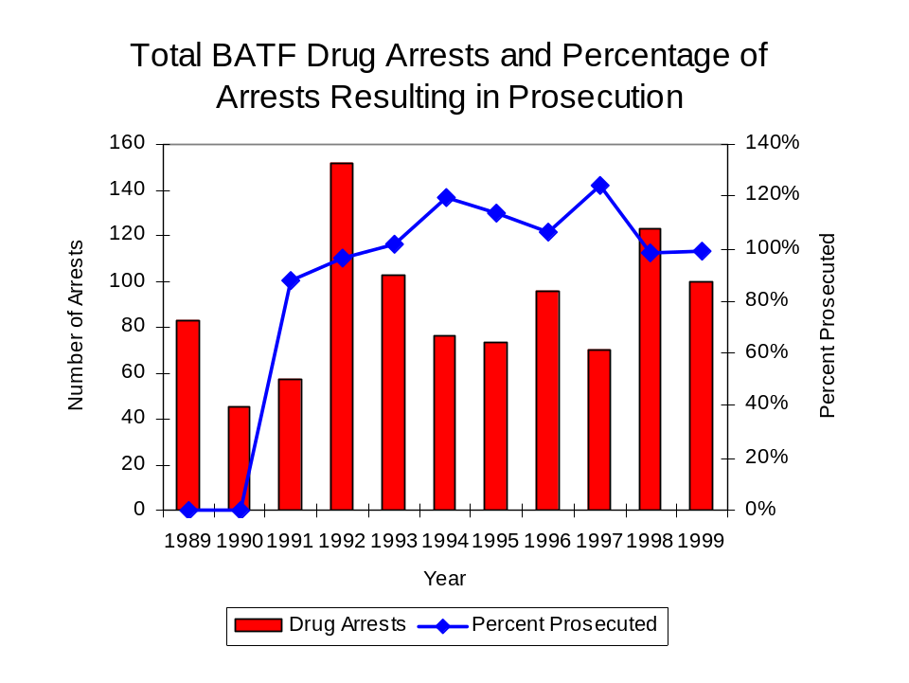
Source: Source: BATF *Prosecution data was not reported prior to 1991
Figure 18

Between 1991 and 1999, the number of convictions (1,446) far exceeded the number of prosecutions (885). This discrepancy may be attributed to the way the task force reported their conviction data. Convictions for controlled substances accounted for 80 percent of all BATF-initiated convictions during the period analyzed.

VI. Trends in Percent of Convicted Drug Offenders Sentenced to Prison

Anyone convicted of a felony in Illinois can be sentenced either to prison or probation, or receive conditional discharge. A number of factors influence the type and length of sentence imposed on convicted felons, including the severity of the crime, the offender’s criminal and social history, safety of the community and legislation affecting certain types of offenses. For some types of convictions, a sentence to prison is required by state statute.

Between 1989 and 1999, the number of offenders convicted of a felony and sentenced in the three-county region covered by BATF increased 61 percent, from 289 to 466. Similarly, the number of convicted felons sentenced to the Illinois Department of Corrections (IDOC) more than doubled between 1989 and 1999, from 86 to 196, while the proportion of felons sentenced to IDOC increased during the same period, from 30 percent to 42 percent of total felony sentences. In 1999, 241 probation sentences were imposed on convicted felons, 24 percent more than in 1989 (Figure 19). However, the proportion of felons sentenced to probation decreased from 67 percent in 1989 to 52 percent in 1999. Sentences other than prison or probation account for the remaining 6 percent of felony sentences imposed in 1999.

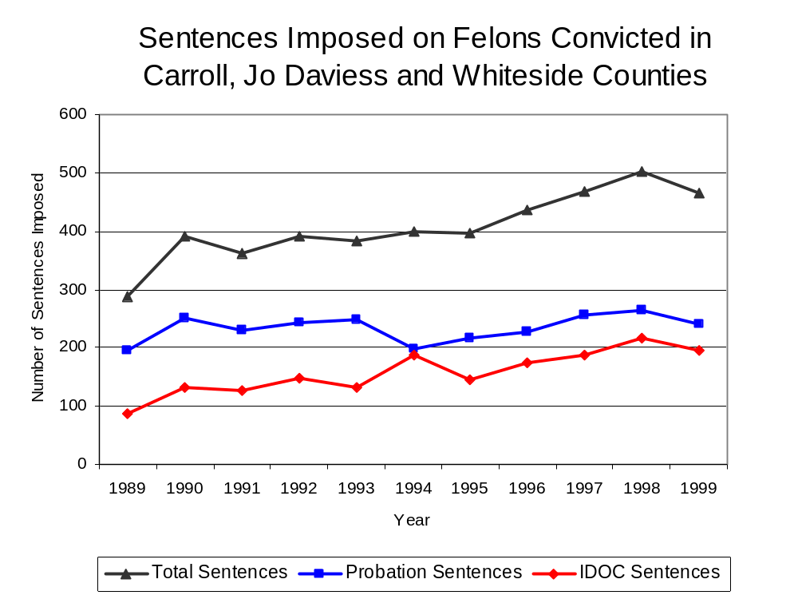
Figure 19
Source: Administrative Office of the Illinois Courts

Between 1991 and 1992, the number of BATF drug offenders convicted and sentenced increased dramatically from 55 to 123, then suddenly dropped to 79 in 1993. Between 1994 and 1999, the number of sentences remained fairly stable, increasing slightly from 70 in 1994 to 76 in 1999. During the period analyzed, the number of convicted BATF drug offenders sentenced to probation decreased from 20 in 1991 to 14 in 1999, with a peak of 52 in 1992. During the same period, the number of convicted BATF drug offenders sentenced to jail increased by a third, from 20 to 30; while the number of convicted BATF offenders sentenced to prison doubled from 15 to 32 (Figure 20). In 1999, among those BATF drug offenders convicted and sentenced, prison sentences accounted for the largest proportion (42 percent), followed by jail sentences (39 percent) and probation sentences (18 percent).

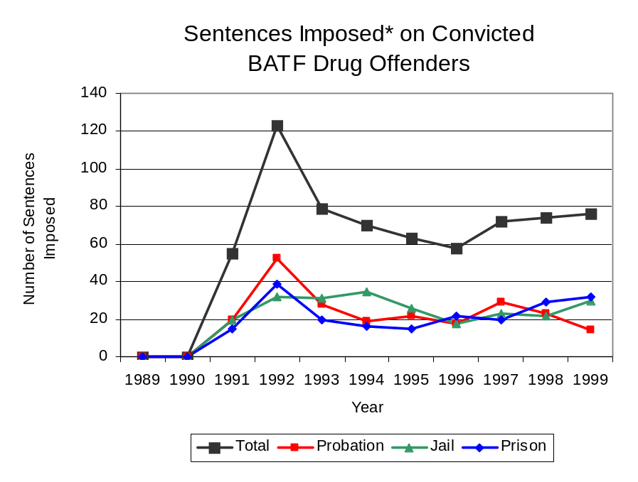
Source: Source: BATF *Prosecution data was not reported prior to 1991
Figure 20

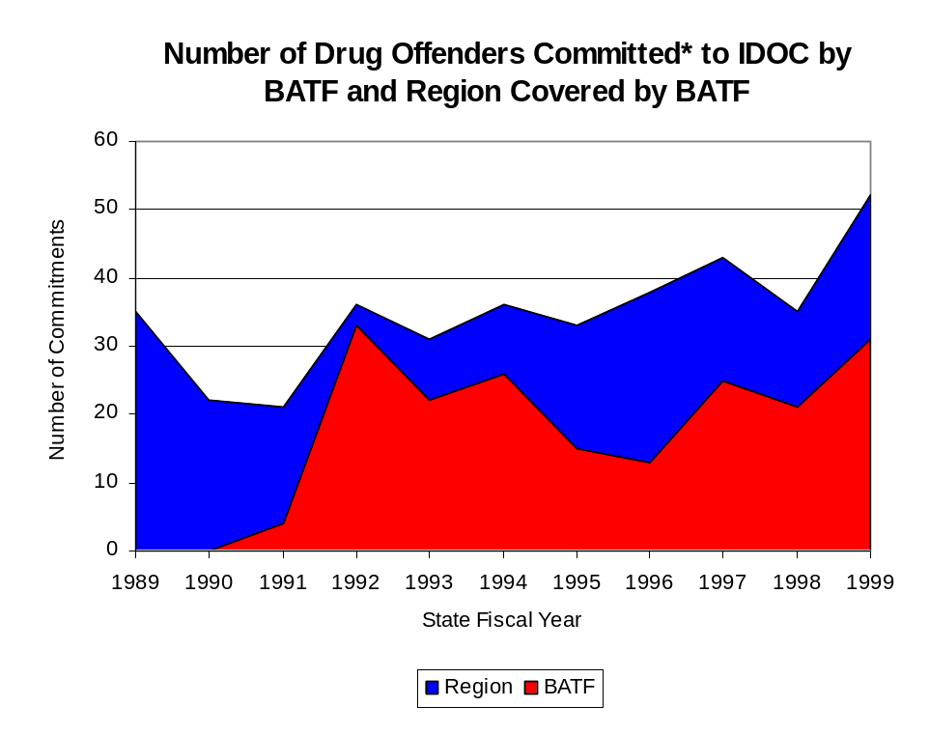
Between state fiscal years* 1989 and 1999, the number of new court commitments to IDOC’s Adult Division for drug offenses from the three-county region covered by BATF increased 49 percent, from 35 to 52. The number of drug offender admissions by BATF also increased from 4 in 1991to 31 in 1999 (Figure 21). Thus, during the period analyzed, prison sentences from BATF cases accounted for 51 percent of all drug-law violators sent to prison from the region where BATF operates.
Source: Illinois Department of Corrections*Commitments data not reported by
and BATF BATF prior to 1991
Figure 21

With the exception of 1989, drug offenders accounted for a fairly stable proportion of adults convicted and sentenced to prison from Carroll, Jo Daviess and Whiteside counties during the period analyzed. In 1989, drug offenses accounted for 32 percent of all commitments to IDOC. This proportion decreased to 20 percent in 1990, and then increased to 24 percent in 1999 (Figure 22).

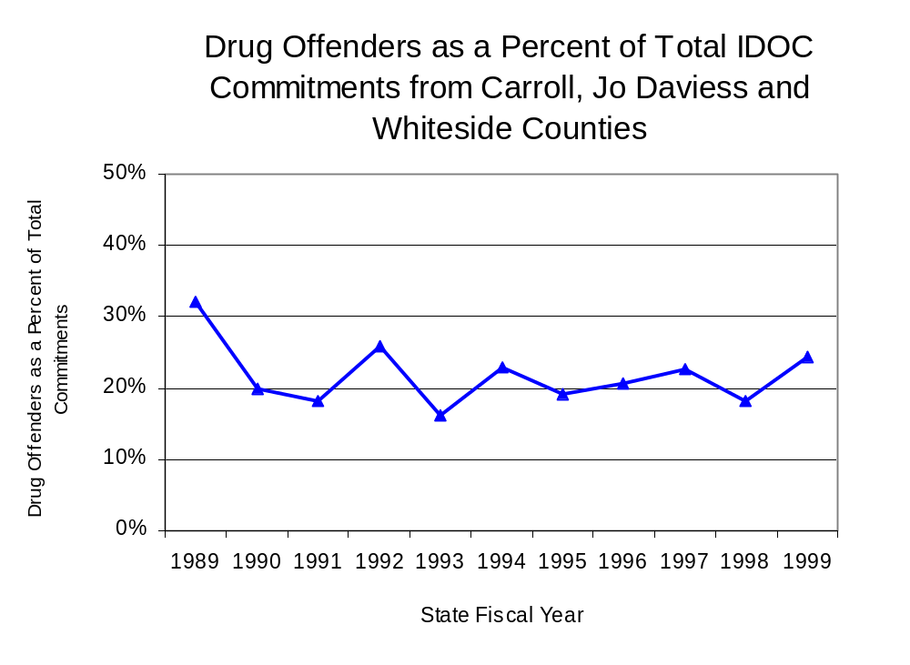
Figure 22
Source: Illinois Department of Corrections

Penalties for drug offenses were also examined between 1993 and 1999. Class 4 felonies accounted for the largest proportion (39 percent) of sentences to IDOC for drug offenses, followed by Class 1 felonies (22 percent), Class X felonies (18 percent), Class 2 felonies (12 percent), and Class 3 felonies (9 percent). Between 1993 and 1999, the number of Class 4 felony sentences increased from 7 to 22, while Class 1 felony sentences increased from 3 to 13. The number of Class X, Class 2 and Class 3 felonies also increased during the period analyzed by small amounts (Figure 23).

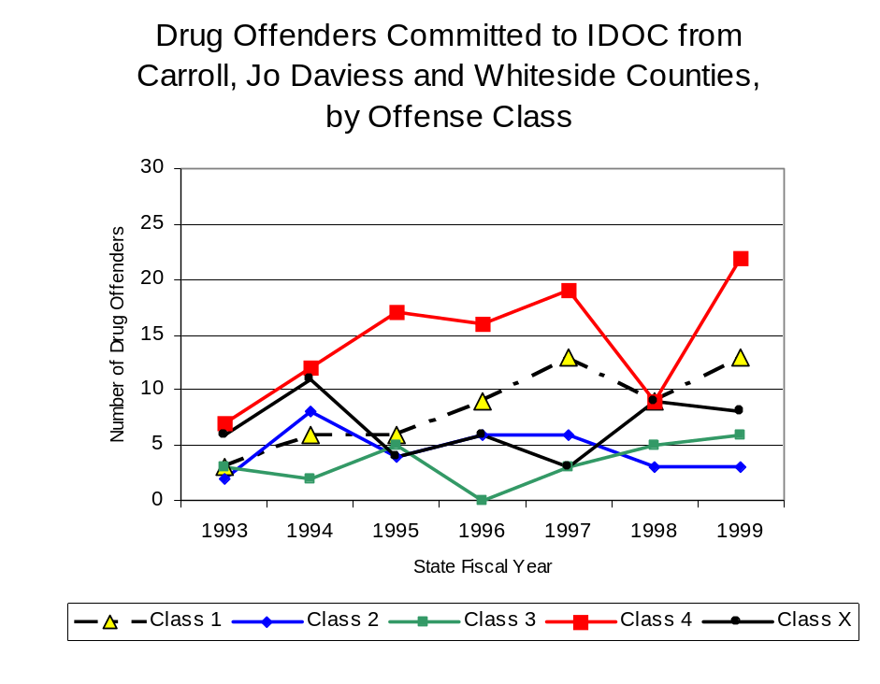
Figure 23
Source: Illinois Department of Corrections

The mean sentence length for Class 4 felonies in 1999 has only increased slightly since 1993 (1.7 to 1.8 years), although this number peaked in 1996 and 1997 at 2.4 years. During the same period, the mean sentence length for Class 1 felonies decreased 22 percent, from 7.7 to 6.0 years. Similarly, mean sentences for a Class X and Class 2 felonies decreased substantially during the period by 40 percent (10.8 to 6.5 years) and 26 percent (5.0 to 3.7 years), respectively. Conversely, the mean sentence length for Class 3 felonies increased from 2.3 to 3.8 years during the period analyzed—a 65 percent increase.

VII. Trends in Drug Treatment Admissions in BATF Region by Drug Type

In addition to considering indicators of the extent and nature of drug abuse as reported through the criminal justice system (for example, arrests and prison sentences), there are indicators of substance abuse available from other Illinois social service agencies. Overseeing and supporting treatment for substance users, whether they are referred from the criminal justice system or elsewhere, is the responsibility of the Illinois Department of Human Services’ Office of Alcoholism and Substance Abuse (OASA). It is important to note, however, that while OASA data represent the majority of the overall demand for substance abuse treatment in the state, some private programs provide treatment services to a smaller but significant number of clients who may not be included in the state’s reporting system.

In 1999, OASA reported 779 admissions for alcohol or drug abuse treatment from Carroll, Jo Daviess and Whiteside counties, 27 percent more than the 611 admissions in 1989 (Figure 24). Among those admissions to substance abuse treatment in 1999, more than half (55 percent) reported alcohol as their primary substance of abuse, while abuse of illicit substances accounted for more than one quarter (26 percent) and 19 percent reported no primary substance of abuse.
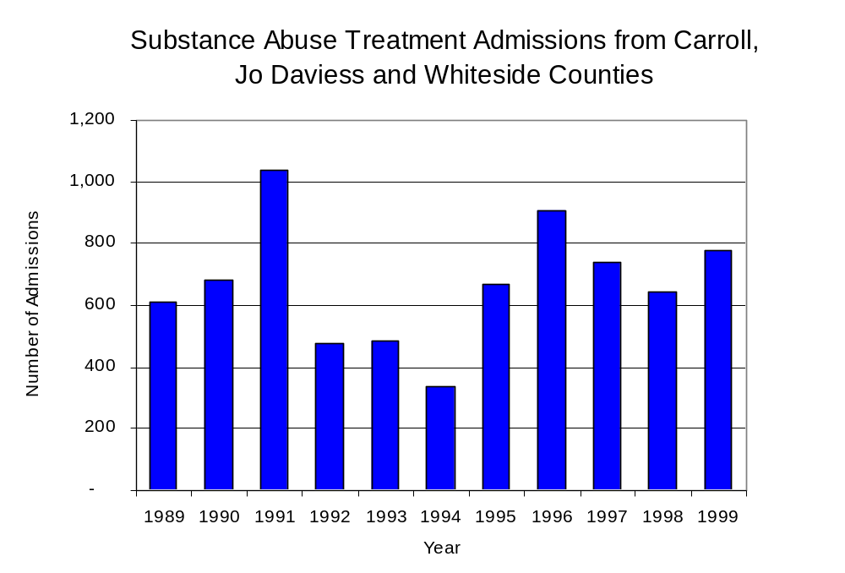
Source: Illinois Department of Human Services’
Office of Alcoholism and Substance Abuse
Figure 24

While drug treatment admissions can be considered a measure of the demand placed on a specific component of the human services system within Illinois, the extent and nature of drug treatment admissions could also be indicative of the substance abuse problem within a particular region. In some respects, the characteristics of those admitted to drug treatment can be considered a profile of the most serious drug abusers in the community, since admission to treatment requires a documented, formal assessment of a drug problem and a level of substance abuse warranting treatment. By comparing the types of drugs of abuse reported by those admitted to substance abuse treatment with the types of drugs involved in law enforcement agency arrests, one can get a sense of the degree to which arrests reflect the drugs which are most problematic within a community.

In the following analyses, the percent of arrests accounted for by drugs classified under Illinois’ Controlled Substances Act (primarily cocaine, heroin, and methamphetamine) versus the Cannabis Control Act (marijuana) across the participating agencies combined, non-participating agencies combined and BATF are compared to the proportion of drug treatment admissions accounted for by these groups of substances. From these comparisons, a number of general conclusions can be made. First, the proportion of arrests made by BATF accounted for by drugs other than marijuana (Controlled Substances Act offenses) was slightly higher than the proportion of drug treatment admissions from the covered region accounted for by these substances. On the other hand, the majority of arrests by local police departments (including those participating in BATF and non-participating agencies) were for cannabis offenses. Thus, while local arrests may reflect the most widely available and used drug in the region, they did not tend to involve the substances considered to be most serious (i.e., felony versus misdemeanor) nor the substances for which a large proportion individuals were seeking and receiving treatment (Figure 25).

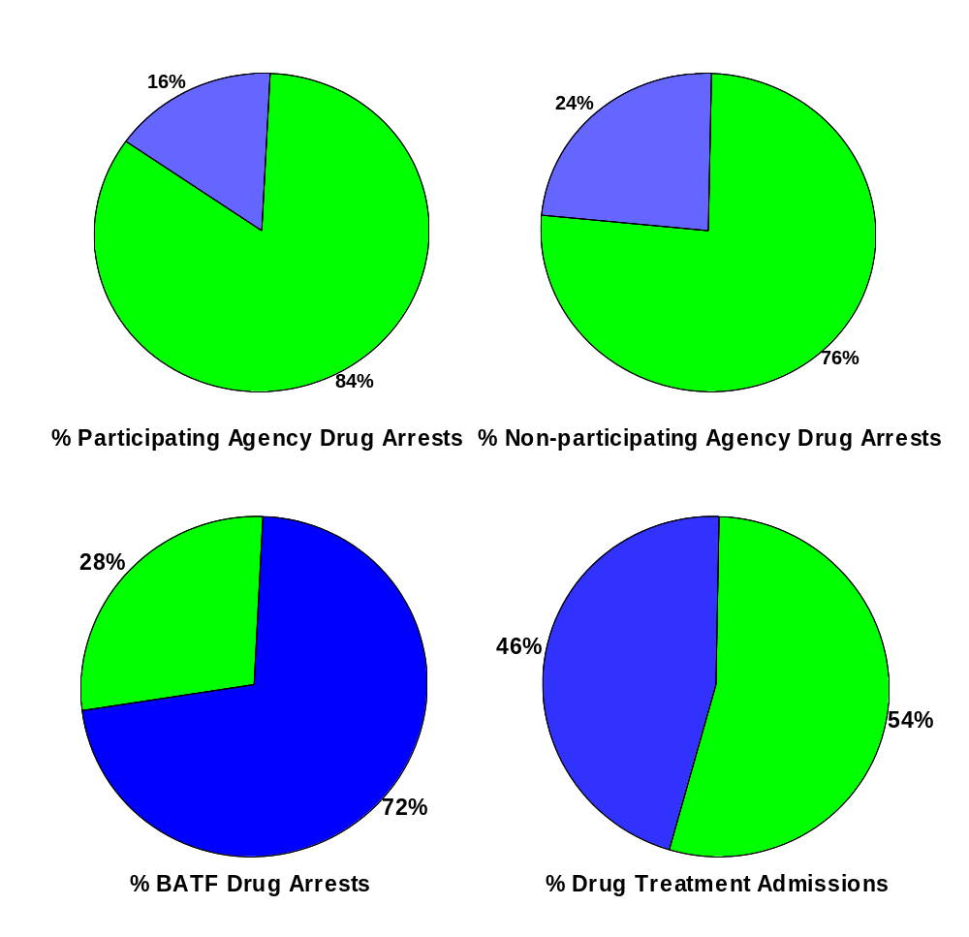
Source: ICJIA calculations using Illinois Department of Human Services’ Office of Alcoholism and Substance Abuse and BATF data

CannabisControlled Substances
Comparison of Drug Arrests by BATF and Participating and
Non-participating Agencies vs. Drug Abuse Treatment Admissions in Carroll, Jo Daviess and Whiteside Counties, 1999
Figure 25

VIII. Trends in Drug Exposed Births

Illinois continues to experience the effects of prenatal substance abuse. In Illinois, if a baby is born and thought to have been exposed to illegal substances or alcohol, either through observation by physicians or toxicology tests, the case is reported to the Illinois Department of Children and Family Services. These cases are then investigated by DCFS to verify the child’s prenatal exposure to either alcohol or illegal substances. Between state fiscal years 1989 and 1999, nearly one-half (50) of Illinois’ 102 counties reported at least one case of a substance-affected infant.

Between state fiscal years 1989 and 1994, the number of drug-exposed infant cases reported in the three-county region covered by BATF increased from one to 14, before decreasing to one case again in 1999. Between state fiscal years 1989 and 1999, 35 cases, or 73 percent of all cases reported, were verified as involving prenatal drug use by a DCFS investigation. Mirroring the trend of reported cases, verified cases of drug-exposed infants in the BATF region also jumped between 1989 and 1994 from one to 10 before dropping to one case again in 1999 (Figure 26).

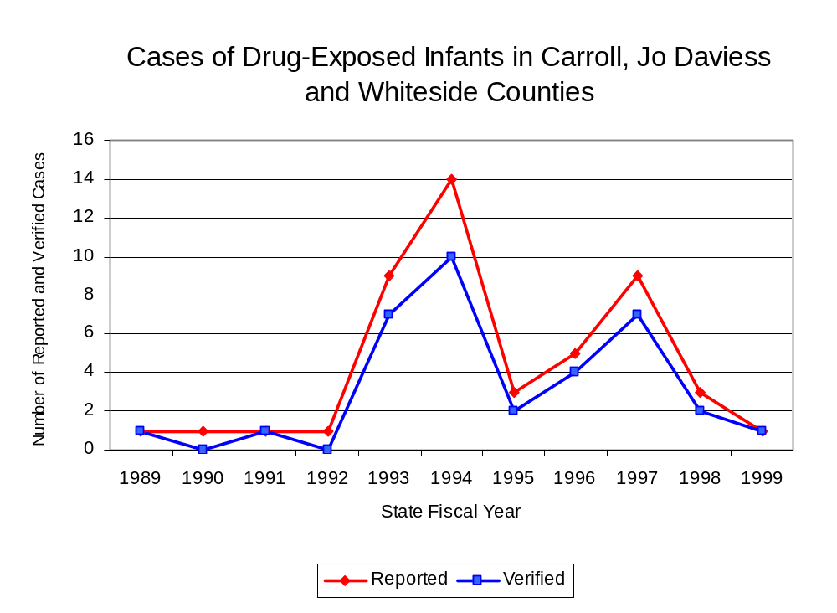
Source: Department of Children and Family Services
Figure 26

IX. Summary of Drug Situation

Although the distribution of illegal drugs is difficult to measure precisely, data obtained from criminal justice sources can be helpful in estimating drug availability. Information from a recent survey of Illinois drug enforcement units, as well as the most up-to-date data available on drug price, are presented as indicators of the drug supply in Illinois.

In 1995, 1996 and 1998, the Authority conducted a survey of each MEG and task force in Illinois to gauge the perceived availability of drugs in the areas they cover. Questions were asked concerning the availability of specific drugs, and results were analyzed by region of the state. MEGs and task forces are classified as being either urban, rural or mixed urban/rural based upon the classification of the county(s) that each unit covers, and, for purposes of this report, are compared to the average of similar units.

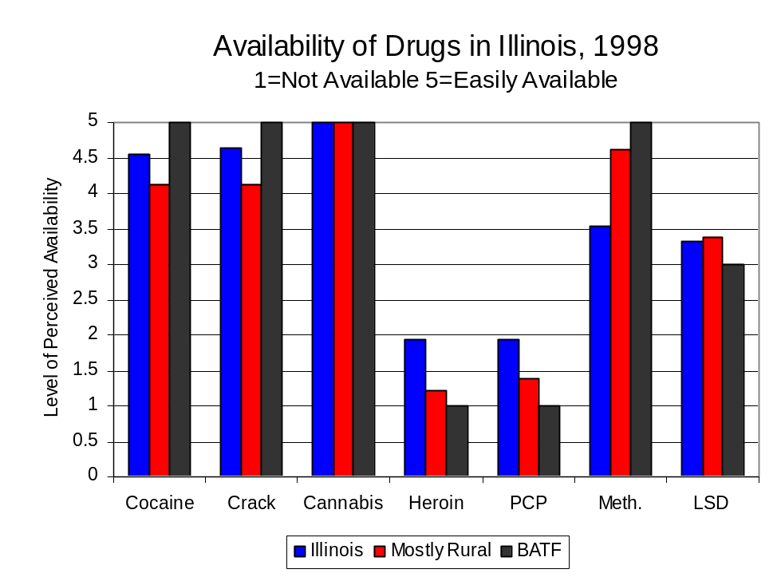
According to BATF survey responses, cannabis, cocaine, crack and methamphetamine continued to be the most visible drugs on the street and were all reported to be “readily available” across all regions analyzed. Since the 1996 survey, the perceived availability of the remaining drugs have decreased in the three-county region covered by BATF. The perceived availability of PCP has decreased from “moderately available” to “not available,” while the perceived availability of heroin and LSD have also decreased slightly. Most other drug types except for LSD appear to have increased slightly across Illinois, while LSD slightly decreased. Conversely, the perceived availability of most other drug types decreased among other MEGs and task forces in mostly rural regions similar to BATF. Methamphetamine was the only drug type to be reported as slightly more available in 1998 than in 1996 within these regions. Methamphetamine was reported as moderately available across Illinois but more readily available in the region covered by BATF and by all MEGs and task forces in mostly rural regions. On the other hand, LSD and heroin appear to be less available in the three-county region covered by BATF than across the state and other MEGs and task forces in similar regions (Figure 27).
Figure 27
Source: Authority Survey of Illinois MEGs and task forces

Another market indicator that can be used to assess availability is drug price. Lower prices tend to suggest a sufficient supply to meet demand, while increasing prices indicate decreased availability.

Based on a statewide survey of MEG and task force units, the average price of cocaine, crack and methamphetamine appear to be relatively stable across all regions surveyed in 1998, while prices for heroin appear to vary somewhat across Illinois. The average price of cocaine, crack and methamphetamine in the region covered by BATF increased between 1996 and 1998. In the other mostly rural regions similar to that covered by BATF, the average price of crack also increased while the average price of heroin decreased by nearly 40 percent ($145 to $88 per gram) between 1996 and 1998. The 1998 average price of cocaine reported by BATF was $100 per gram, compared to $98 per gram across Illinois as well as by all MEGs and task forces in other mostly rural regions (Figure 28). On the other hand, the average price of heroin in the region covered by BATF was reported as $100 per gram. This is lower than the price of $165 per gram across Illinois yet higher than the price of $88 per gram reported by all other MEGs and task forces in mostly rural regions.
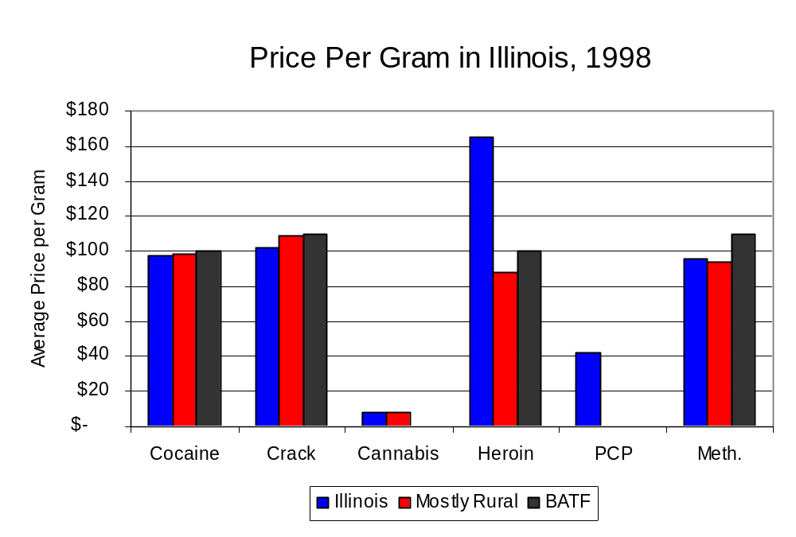
Figure 28
Source: Authority Survey of Illinois MEGs and task forces

X. Appendices
1999 Percent of Illinois'
County-level Population Covered by an Authority-funded Multi-jurisdictional Enforcement Group or Task Force
Map 1
* Shaded counties indicate that at least one law enforcement agency within the county participates in a MEG or task force
Percent of County Population Covered by MEG or Task Force

1999 Illinois
Cannabis
Seizure Rates, by County
Map 2
Cannabis Seizure Rate
(rate per 100,000 population)
1999 Illinois
Cocaine
Seizure Rates, by County
Map 3
Cocaine Seizure Rate
(rate per 100,000 population)
1999 Illinois Methamphetamine
Seizure Rates, by County
Map 4
Methamphetamine Seizure Rate
(rate per 100,000 population)

Bibliography

Administrative Office of the Illinois Courts, Annual Report to the Supreme Court of Illinois.
1989 through 1999 reports, Springfield, Illinois.

Administrative Office of the Illinois Courts’ Probation Division, Statewide Probation Data
Report. 1989 through 1999 reports, Springfield, Illinois.

Illinois Department of Human Services’ Office of Alcoholism and Substance Abuse. Data
provided for state fiscal years 1989 through 1999, Springfield, Illinois.

Illinois Department of Children and Family Services, Child Abuse/Neglect Statistics Report,
1989 through 1999 reports, Springfield, Illinois.

Illinois Department of Corrections. Data provided for fiscal years 1989 through 1999,
Springfield, Illinois.

Illinois State Police, Crime in Illinois. 1993 through 1999 reports, Springfield, Illinois.

Illinois State Police, Drug Statistics Report. Monthly reports, January 1989 through
December 1999, Springfield, Illinois.

Blackhawk Area Task Force. Monthly reports, February 1989 through December
1999, Sterling, Illinois.

U.S. Bureau of the Census.


George H. Ryan, Governor
Peter B. Bensinger, Chairman
Candice M. Kane, Executive Director

* Some state data are collected according to State Fiscal Year (SFY) instead of calendar year. SFYs begin on July 1st and end the following June 30th, and are named according to the calendar year between January and June, e.g. state fiscal year 1991 was from July 1st, 1990 to June 30th, 1991.

